Bahria University,

Karachi Campus



LAB EXPERIMENT NO.

**05**

LIST OF TASKS

|  |  |
| --- | --- |
| TASK NO | OBJECTIVE |
| 1 | **Write a python program that can find the value of tan(0.12) using Newton’s forward interpolation formula, with considering to the following data points:** |
| 2 | **Write a python program implementing the backward interpolation formula that considers the following data points, and a. Find the value of y at x = 300  b. Find the value of y at any given user input** |

**Task 1: Write a python program that can find the value of tan(0.12) using Newton’s forward interpolation formula, with considering to the following data points:**

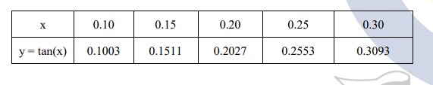

**Solution**

**Task 2: Write a python program implementing the backward interpolation formula that considers the following data points, and  
a. Find the value of y at x = 300   
b. Find the value of y at any given user input**

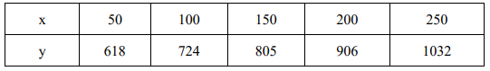

**Solution**

**a. Find the value of y at x = 300**

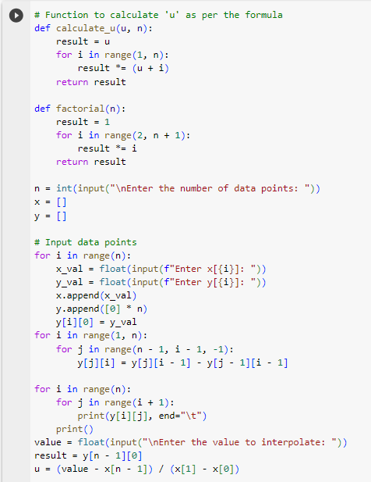



**b. Find the value of y at any given user input.**

